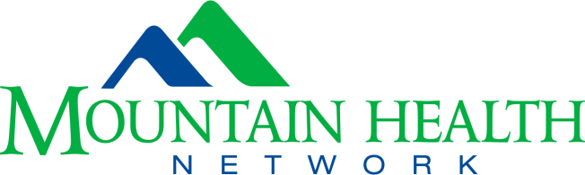

MOUNTAIN HEALTH NETWORK, INC. (MHN) TUITION ASSISTANCE
Semester Completion Form

Name: | Date:
Mailing address: | Phone:  E-Mail:
School Name: | School Address:
School Program: | Program Length: (specify 2 or 4 year):
Did you complete all semester courses with a grade of “C’ or better? | How many semesters remain to be completed before eligibility to graduate?
Projected graduation date: | Student account number:

All items below must be included with semester completion form:

____ Unofficial transcript that includes most recent completed semester grades

____ Proof of enrollment for upcoming semester (such as printed schedule/dates of classes)

____ Proof of cost (includes tuition and fees)

***Proof of cost and enrollment documents must identify the school term, name of institution and employee’s name. These two items are not required for students in St. Mary’s School of Medical Imaging, Respiratory, or Nursing.

Submit all documentation to:
E-mail address: alrena.labus@st-marys.org

Applicant Signature Date

